

**The Superior University**

**Name: Sarah Ch**

**Roll No**: 097

**Section**: 4B

**Submitted to:** Sir Raskhi

**N-Queen**

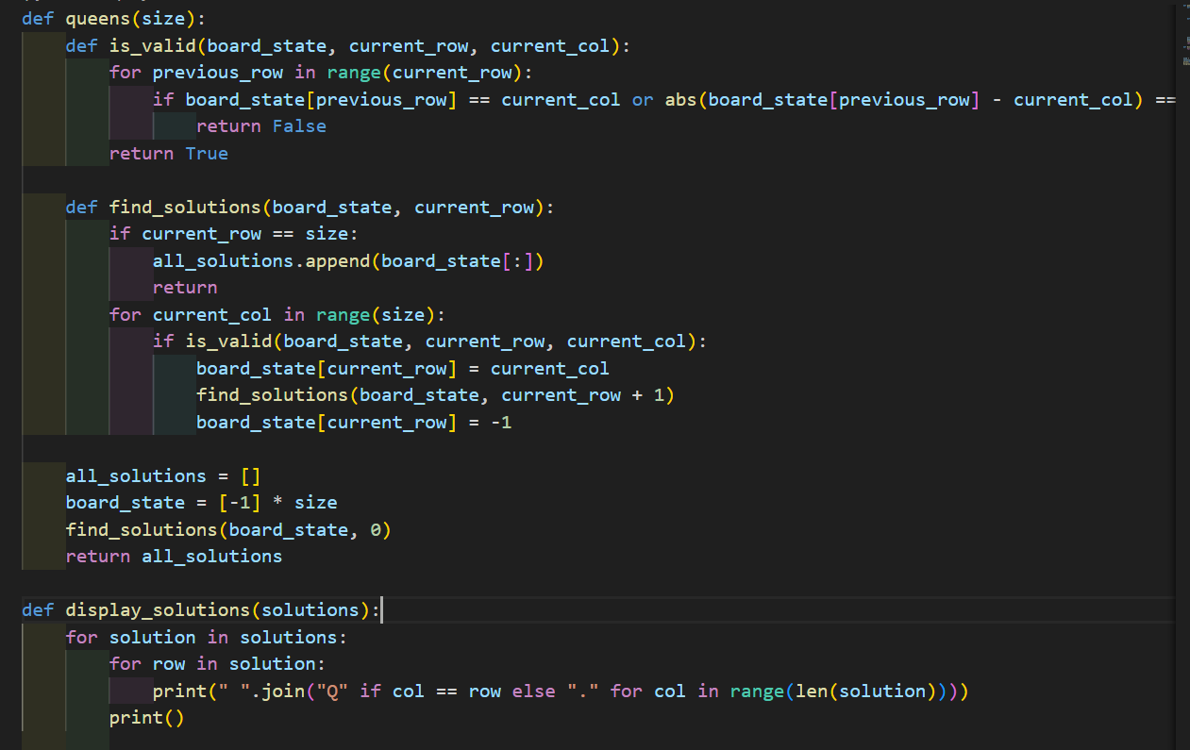

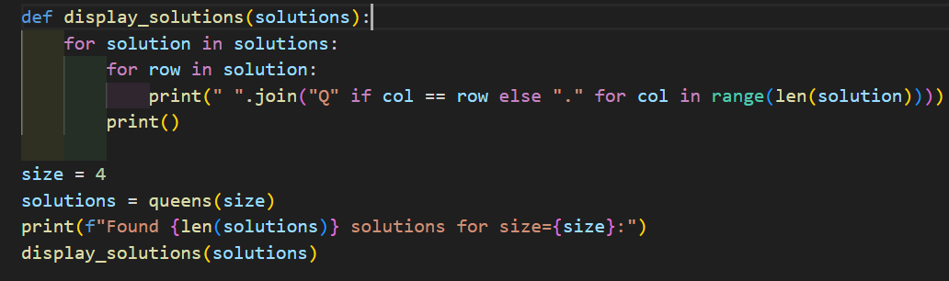

**Output:**

